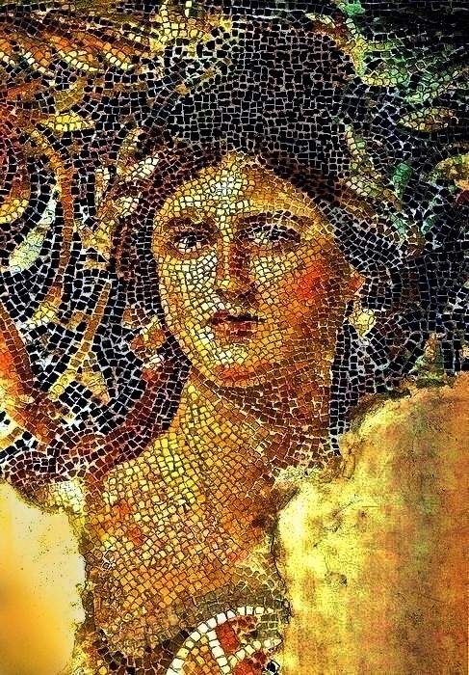
etrusca Wines
Our limited production 2017 Etrusca Cecilia was sourced from small, family owned sources growing in the famed Russian River Valley AVA. In the glass, this exciting cuvee of Chardonnay offers a brilliant rich, bright straw-colored hue. The delicate, aromatic nose hints of honey, citrus blossom, grapefruit, wet stone and vanilla bean. The opening palate is bright and focused, with a refined texture. The mid-palate shows white grapefruit rind, white peach and citrus peel followed by floral notes. The wine is mouth-watering, with a bright refreshing acidity. The finish is palate cleansing, with a pleasant minerality, offering lifting notes of citrus zest. This wine is an outstanding pair and counterpoint to your favorite richly flavored and buttery textured seafood and vegetable dishes.
Wine Data:

Wine: 2017 Etrusca Cecilia Chardonnay
Wine Composition: 100% Chardonnay
AVA: Russian River Valley, Bazzano Vineyards
Aging: 14 mos./100% French oak cooperage/ 25% new barrels
Alc. 14.0%
Cases Produced: 125

Etrusca Wines Santa Rosa, CA www. etruscawines.com P. 707.542.5892 F. 707.545.7536

